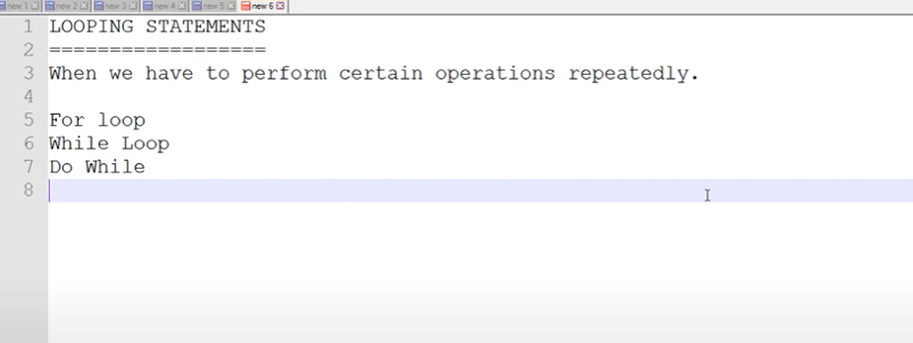

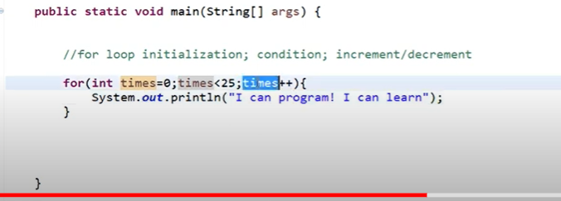

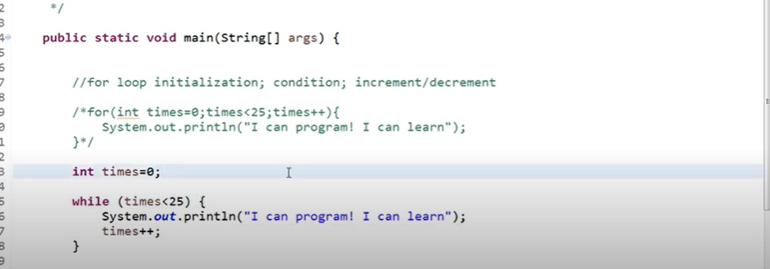

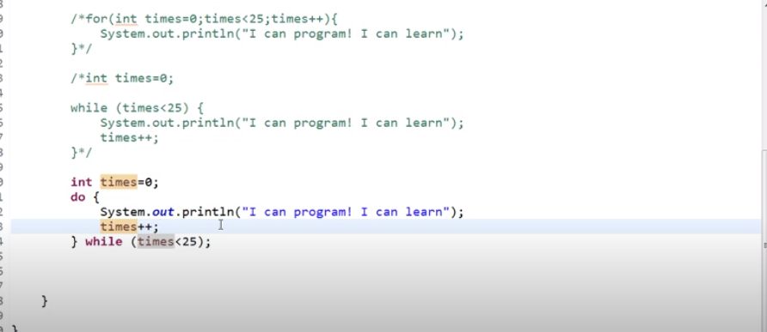

===============================================================================

Conditional statement:

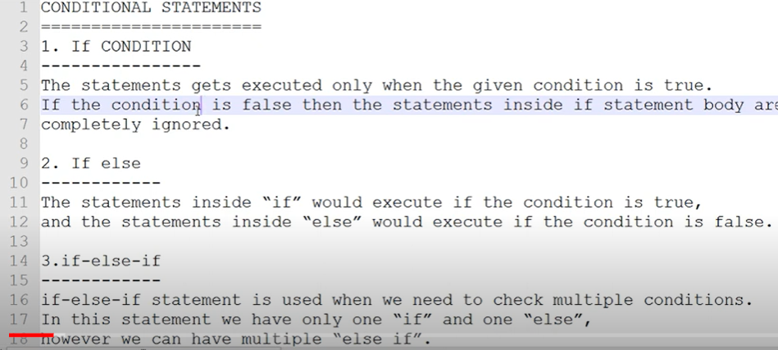

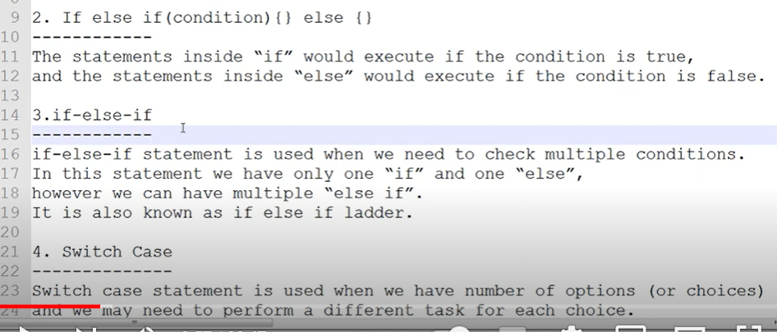

If

----

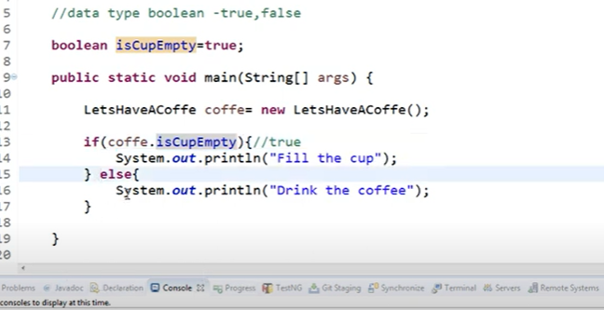

IF else

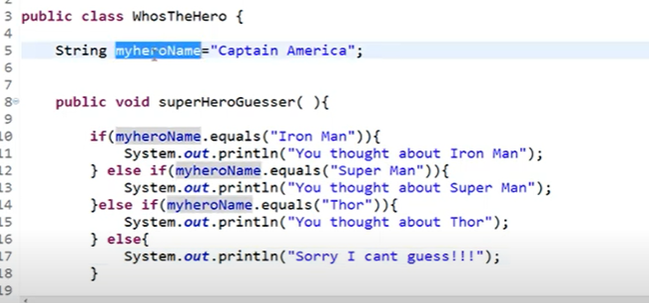

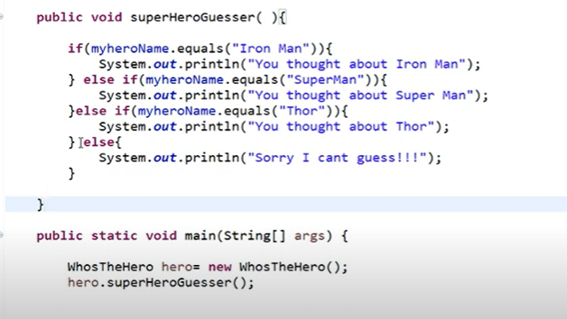

Switch Case:

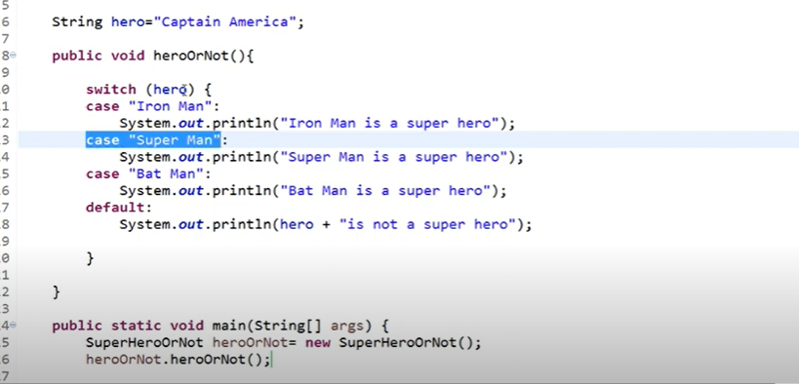

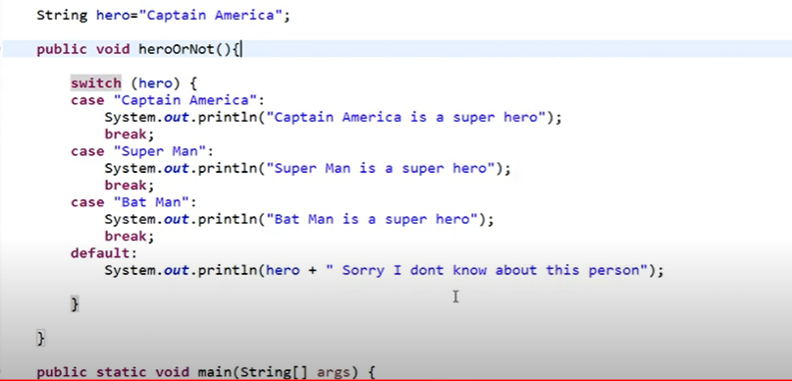

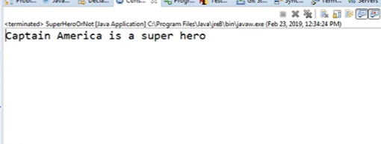

STATIC Key Word

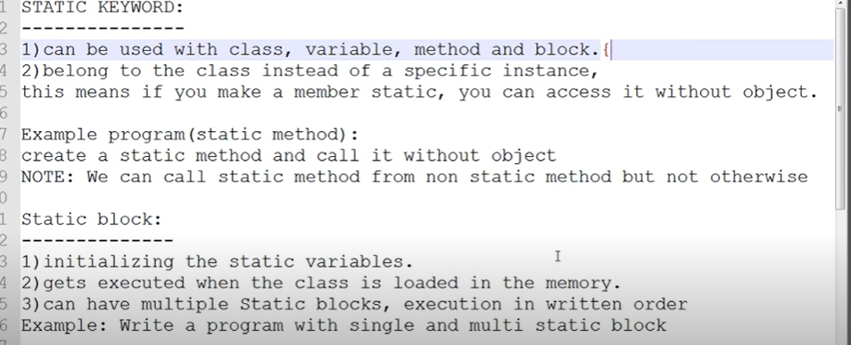

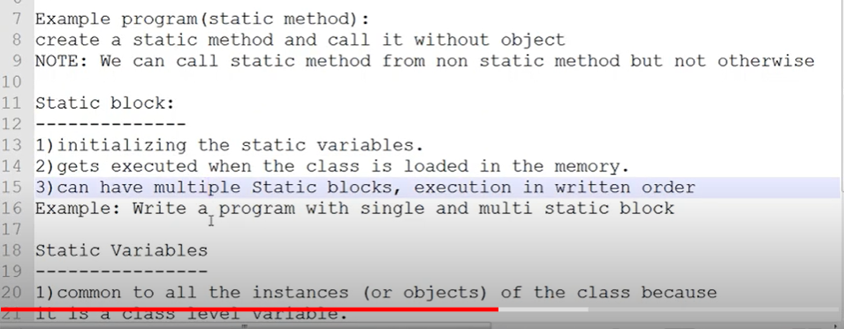

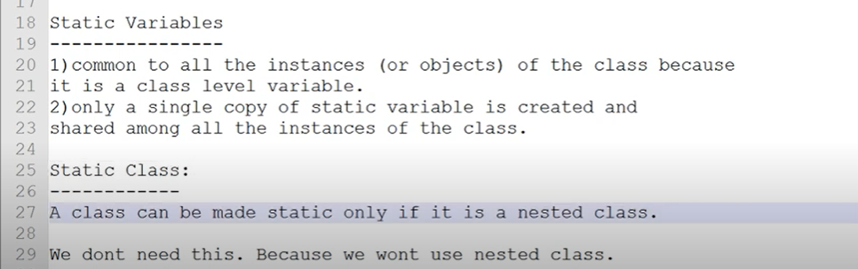

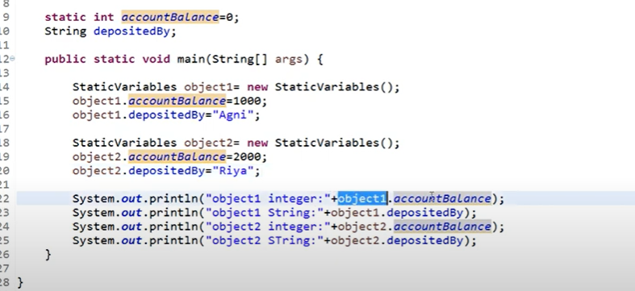

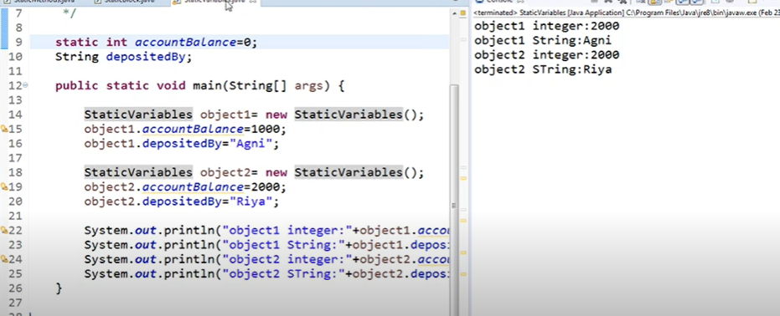

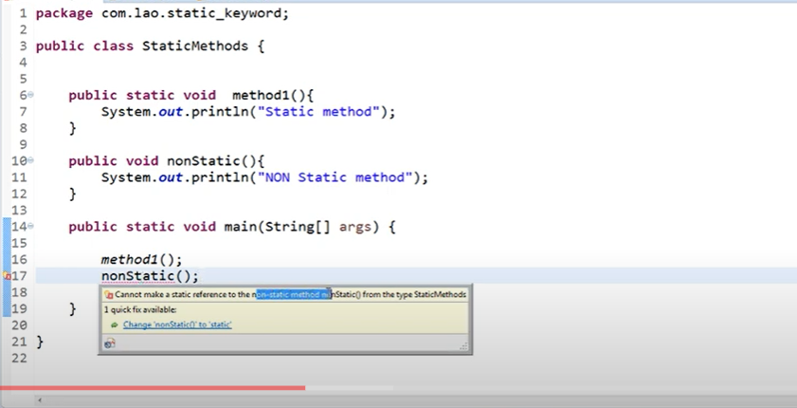

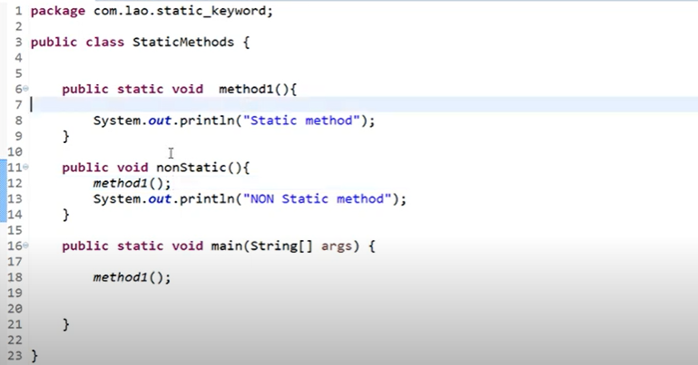

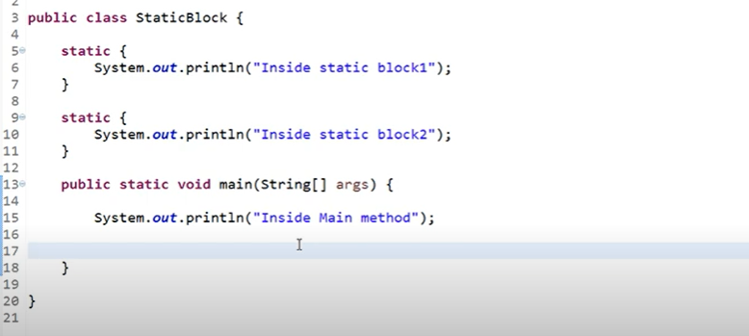

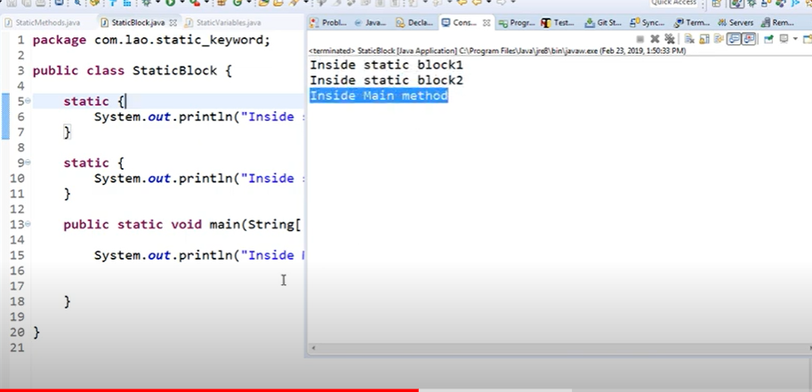

Inheritance

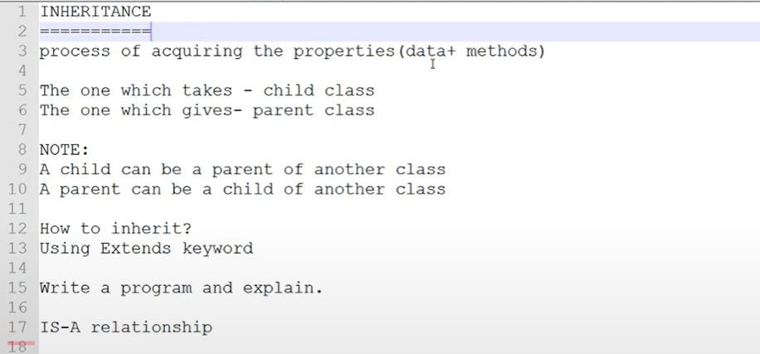

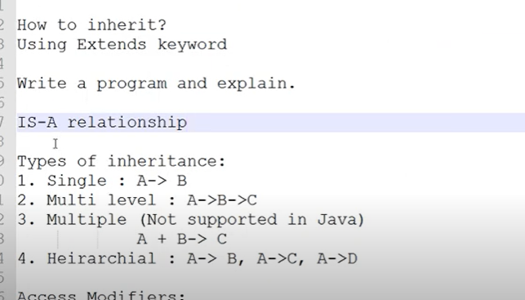

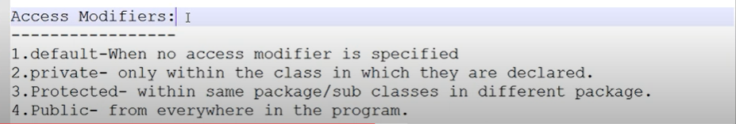

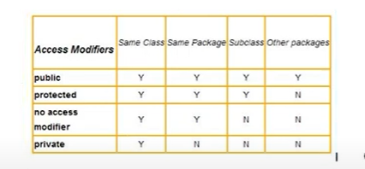

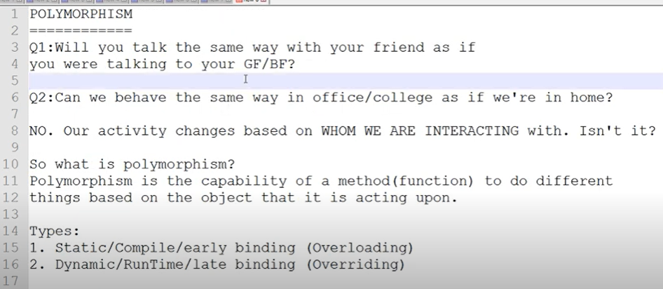

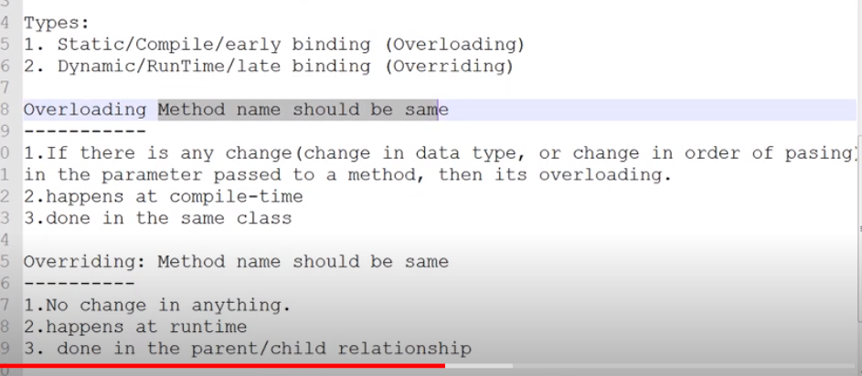

Over loading

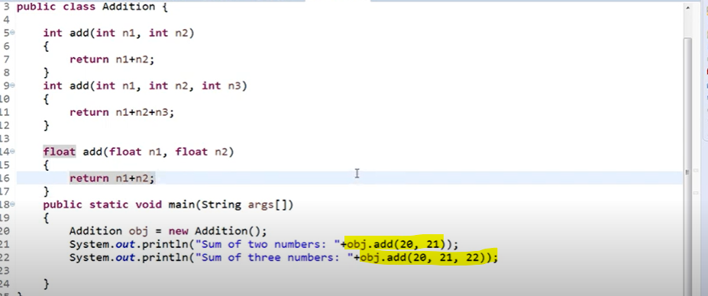

Over Riding

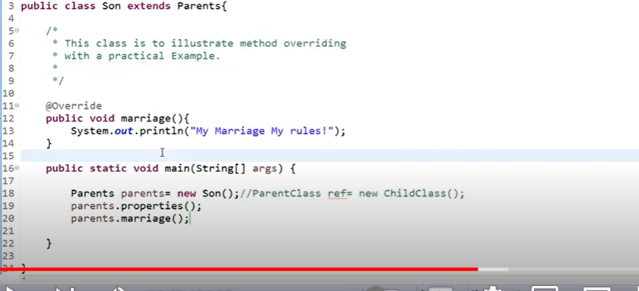

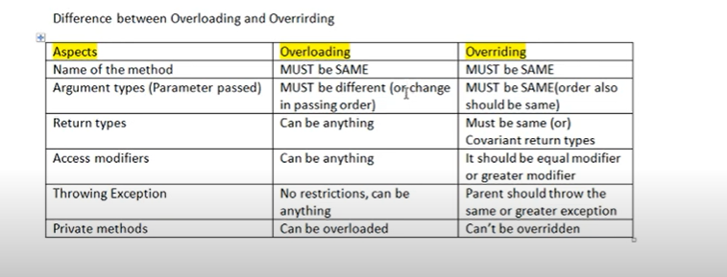

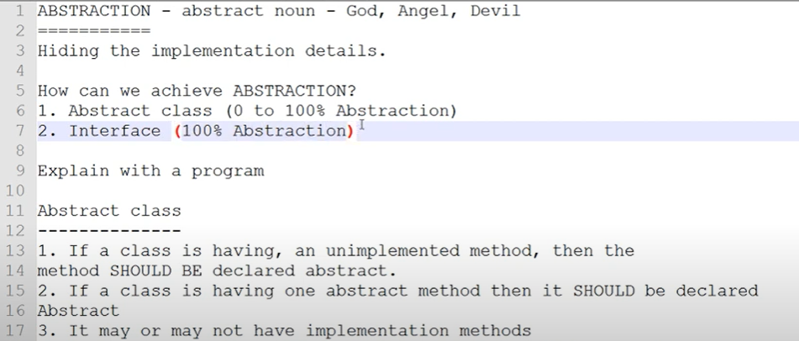

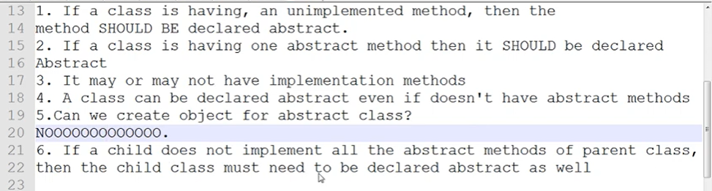

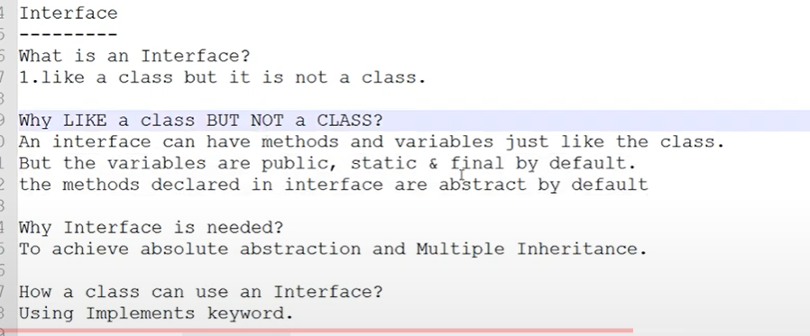

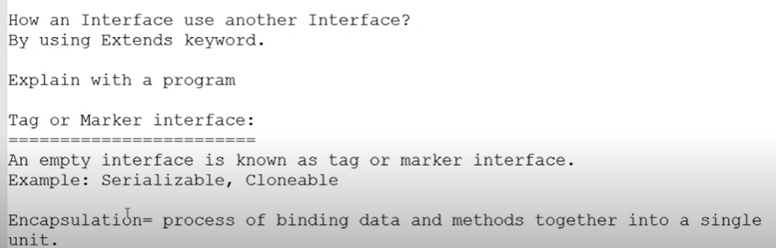

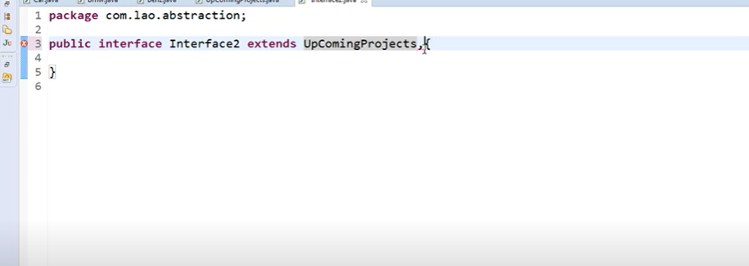

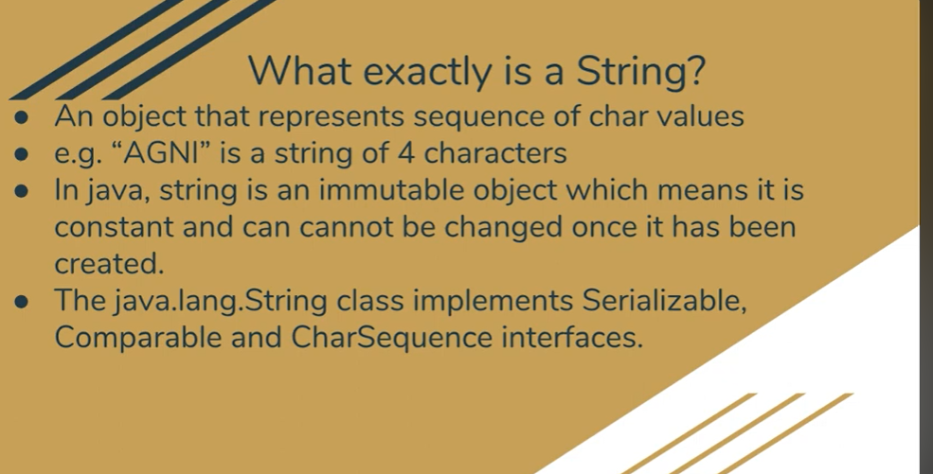

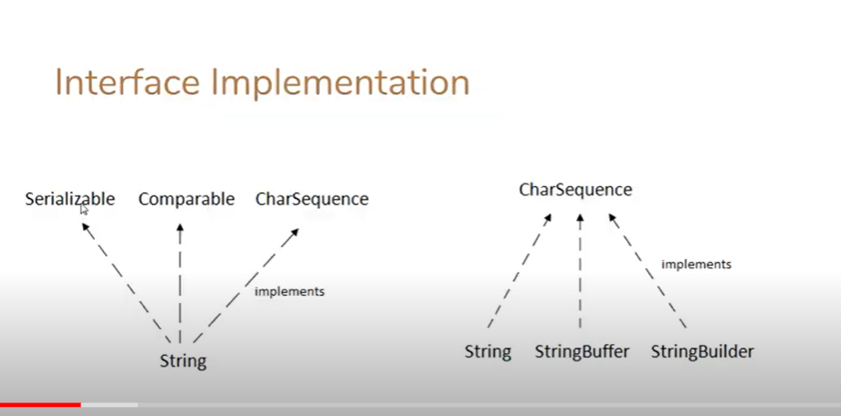

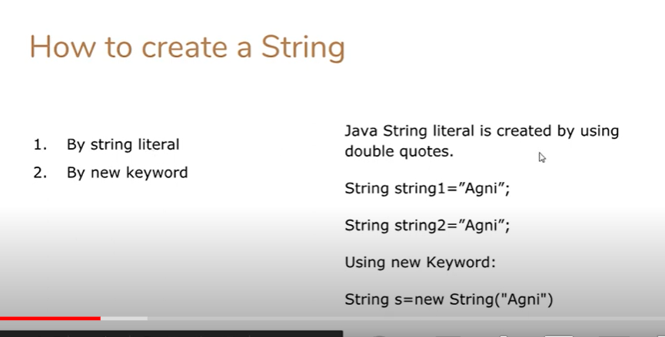

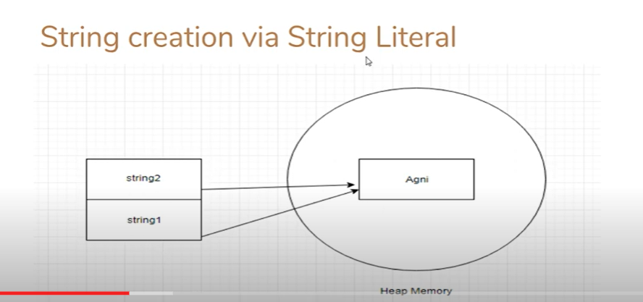

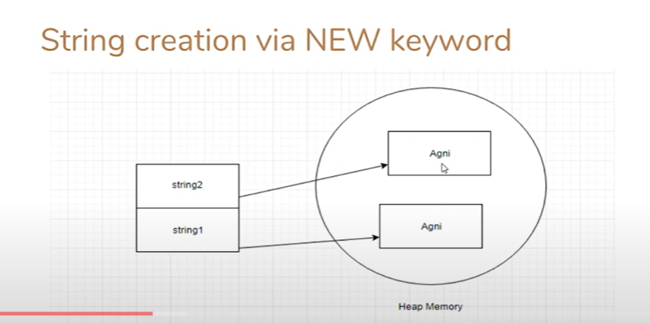

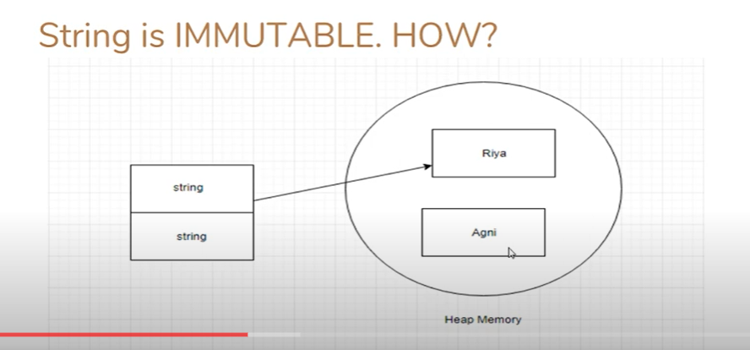

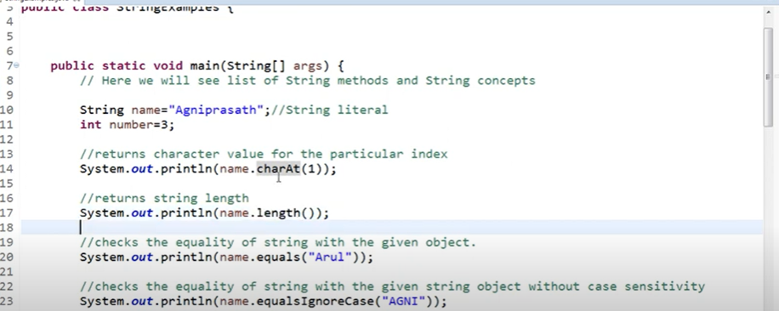

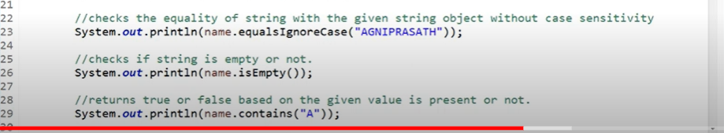

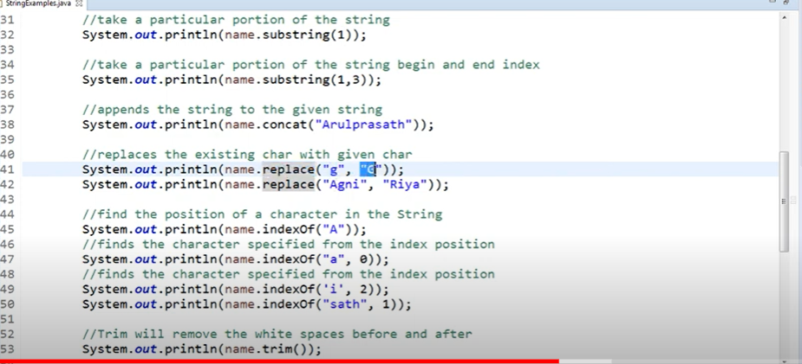

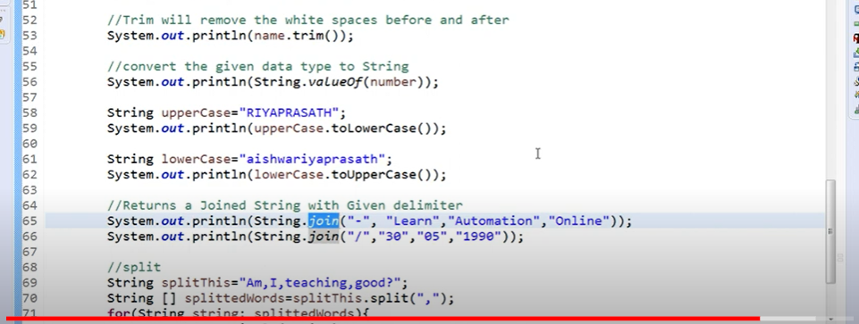

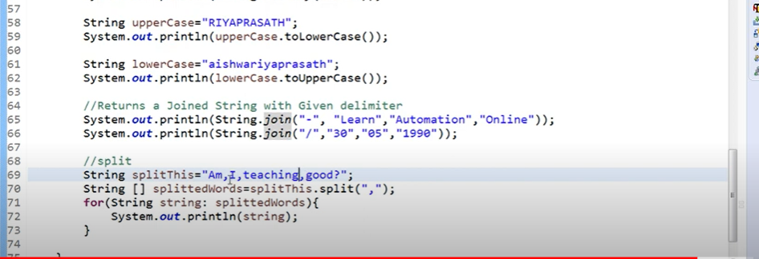

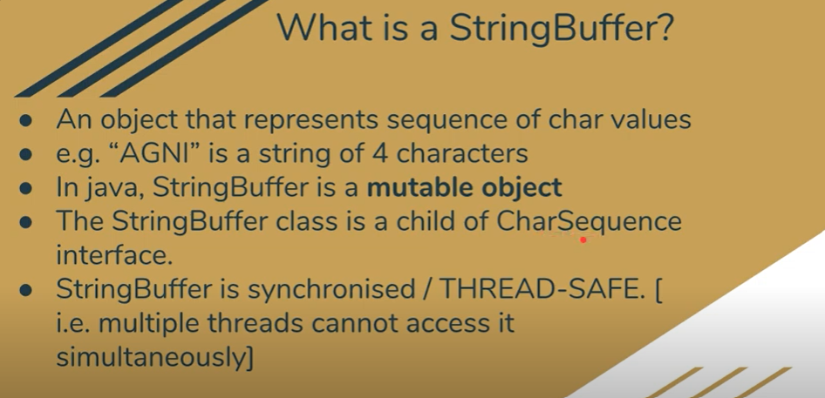

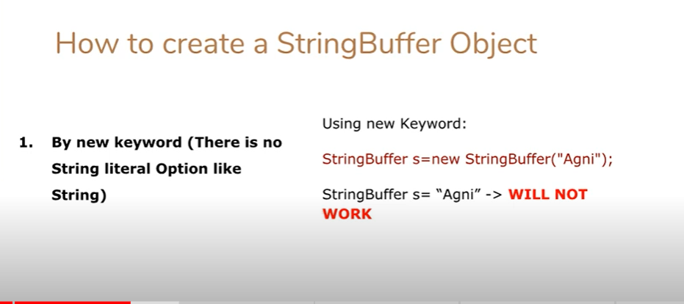

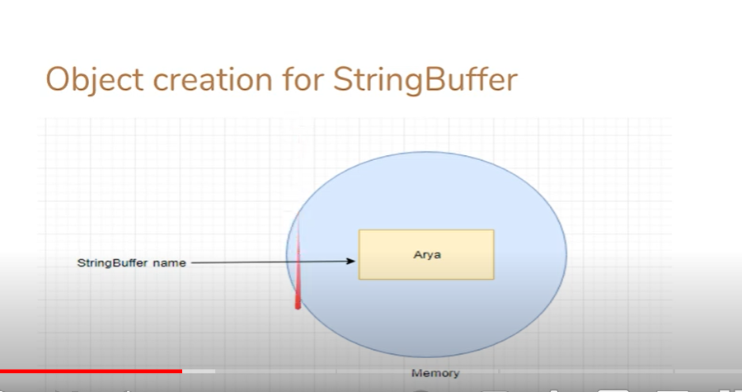

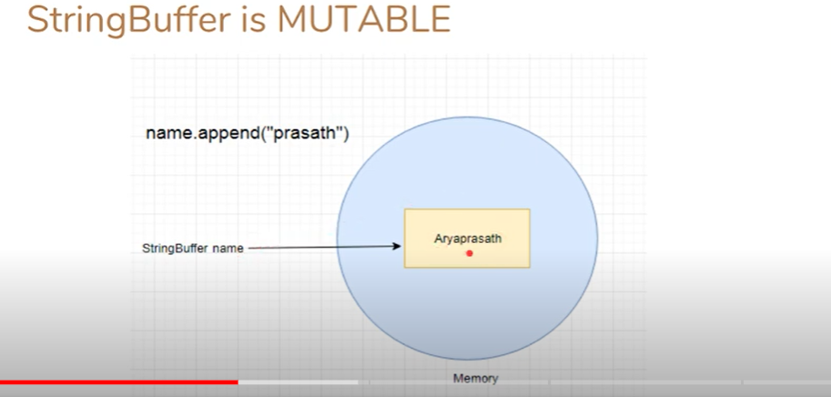

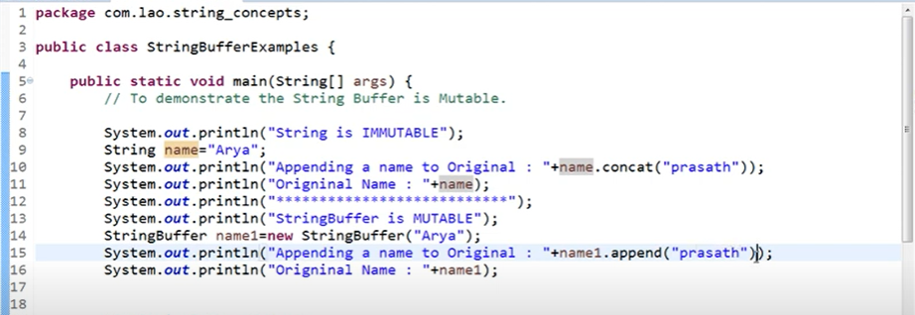

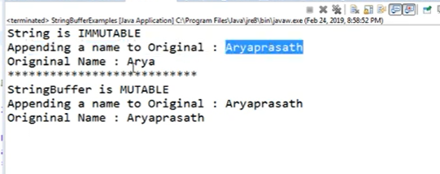

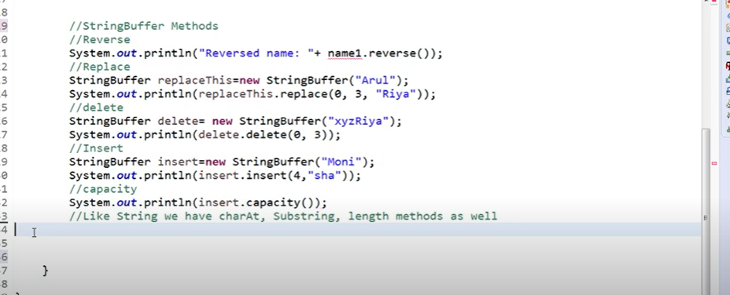

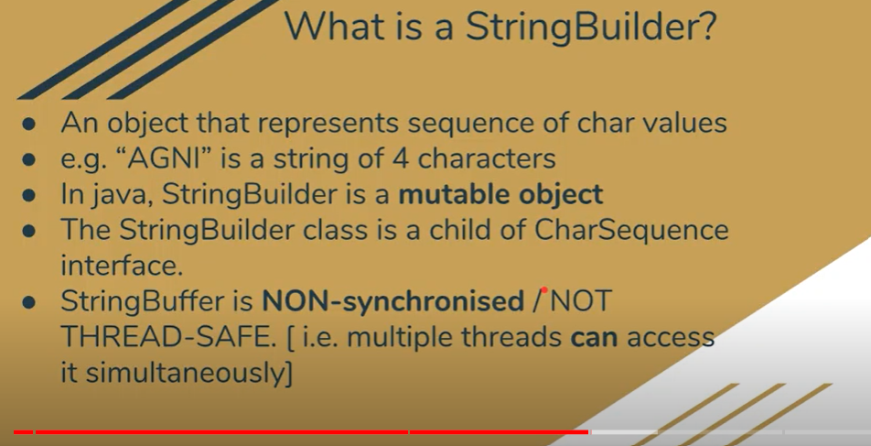

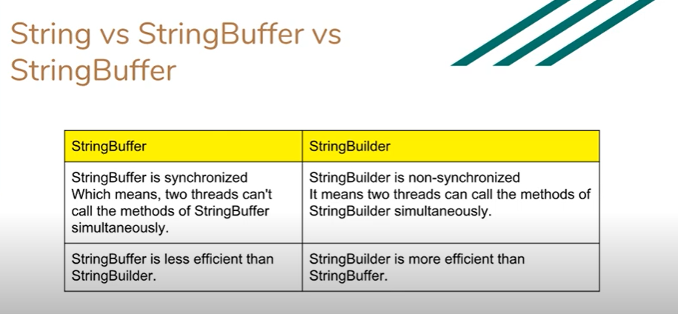

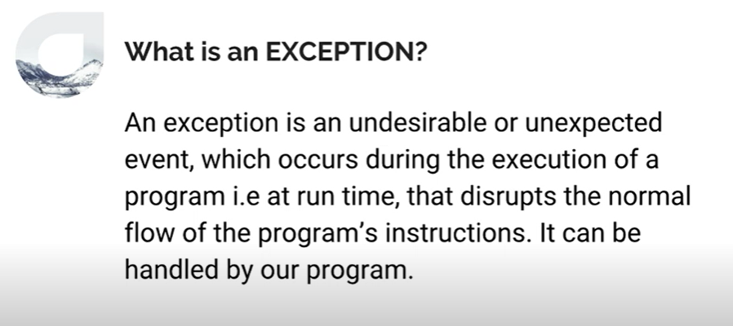

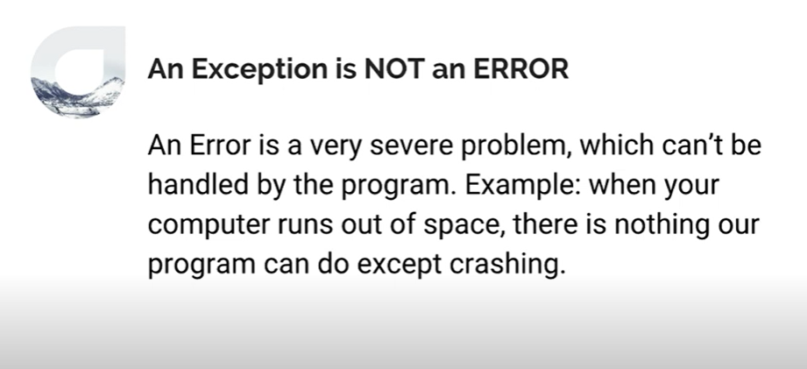

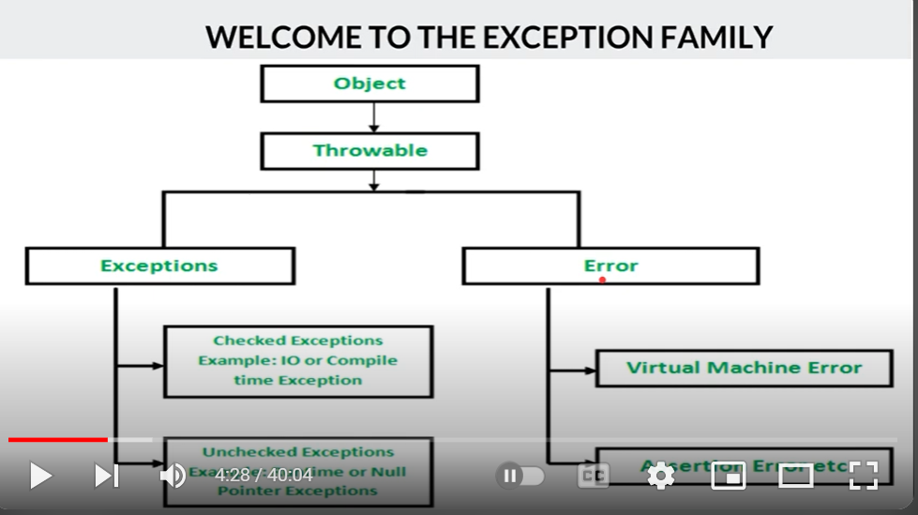

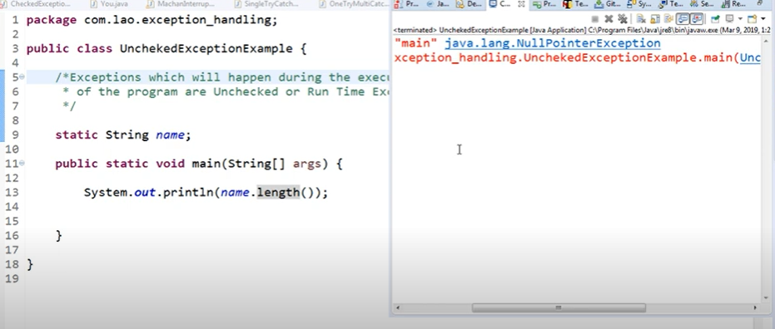

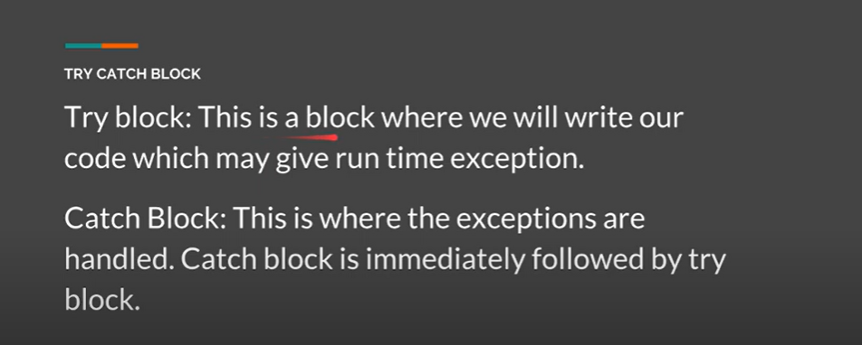

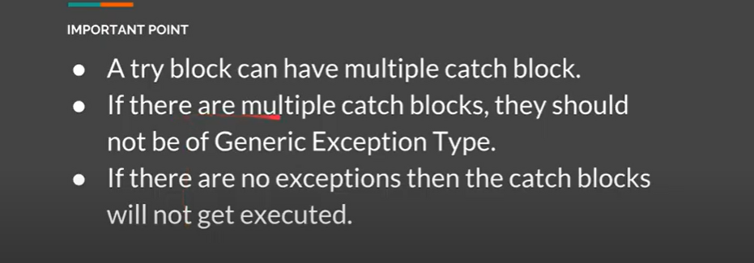

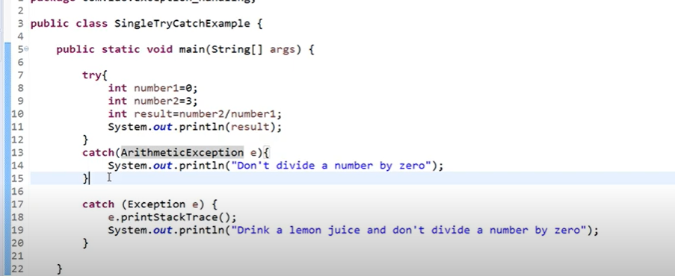

**1. Fibnocci seriers**

**======================**

**class HelloWorld {**

**public static void main(String[] args) {**

**int n1=0,n2=1,n3,i,count;**

**System.out.println(n1);**

**System.out.println(n2);**

**for(i=2; i<=15;i++)**

**{**

**n3=n1+n2;**

**System.out.println(n3);**

**n1=n2;**

**n2=n3;**

**}**

**}**

**}**

**=========================================================================================**

**2. Factorial**

**================**

**class HelloWorld {**

**public static void main(String[] args) {**

**int i,fact=1;**

**int number=5;//It is the number to calculate factorial**

**for(i=1;i<=number;i++){**

**fact=fact*i;**

**}**

**System.out.println("Factorial of "+number+" is: "+fact);**

**}**

**}**

**============================================================================================**

**3)Find the duplicate words and their number of occurrences in a string?**

**With Iteration**

**--------------**

**class HelloWorld {**

**public static void main(String[] args) {**

**String str="Reniston";**

**char ch='n';**

**int occurence=0;**

**str=str.lowerCase();**

**for(int i=0; i<str.length(); i++)**

**{**

**if(str.charAt(i)==ch)**

**occurence++;**

**}**

**System.out.println("n occurs "+occurence);**

**}**

**WithOut Iteration**

**-----------------**

**class HelloWorld {**

**public static void main(String[] args) {**

**String str="Reniston";**

**char ch='n';**

**String strch=Character.toString(ch);**

**str=str.toLowerCase();**

**int lengthOfOriginal=str.length();**

**System.out.println(lengthOfOriginal);**

**str=str.replace(strch,"");**

**System.out.println(str.length());**

**}**

**}**

**}**

**========================================================================================**

**4) Write a Java program to count the number of words in a string?**

**Number of Sentence present in the string**

**---------------------------------------**

**class HelloWorld {**

**public static void main(String[] args) {**

**String str="I am a mom";**

**String y[]=str.split(" ");**

**System.out.println(y.length);**

**}**

**}**

**===============================================================================================**

**5) Write a Java program to count the total number of occurrences of a given character in a string without using any loop?**

**WithOut Loop**

**===================**

**class CountCharacterOccurence**

**{**

**public static void main(String[] args)**

**{**

**String s = "Java is java again java again";**

**char c = 'a';**

**int count = s.length() - s.replace("a", "").length();**

**System.out.println("Number of occurances of 'a' in "+s+" = "+count);**

**}**

**}**

**With Loop Number of char in a string**

**------------------------------**

**class HelloWorld {**

**public static void main(String[] args) {**

**String str="Reniston";**

**int occurance=0;**

**for(int i=0;i<str.length();i++)**

**{**

**if(str.charAt(i)!=' ')**

**occurance++;**

**}**

**System.out.println(occurance);**

**}**

**}**

**==============================================================================================**

**6) Write a Java program to reverse a string?**

**class HelloWorld {**

**public static void main(String[] args) {**

**String str= "Malayalam", reversed="";**

**char ch;**

**for (int i=0; i<str.length(); i++)**

**{**

**ch= str.charAt(i);**

**reversed= ch+reversed;**

**}**

**System.out.println("Reversed word: "+ reversed);**

**if(str==reversed)**

**{**

**System.out.println("palindrome");**

**}**

**else**

**{**

**System.out.println("Notpalindrome");**

**}**

**}**

**}**

**Reverse the number**

**==================**

**class HelloWorld {**

**public static void main(String[] args) {**

**int number = 987654, reverse = 0;**

**while(number != 0)**

**{**

**int remainder = number % 10;**

**reverse = reverse * 10 + remainder;**

**number = number/10;**

**}**

**System.out.println("The reverse of the given number is: " + reverse);**

**}**

**}**

**How to reverse a sentence word by word in Java?**

**=============================================================**

**class HelloWorld {**

**public static void main(String[] args) {**

**String str="I am a mom", Reversed="";**

**String y[]=str.split(" ");**

**System.out.println(y.length);**

**for(int i=y.length-1; i>=0;i--)**

**{**

**Reversed=Reversed+y[i]+" ";**

**}**

**System.out.println(Reversed);**

**}**

**}**

**sorry am I**

**------------------------------------------**

**class HelloWorld {**

**public static void main(String[] args) {**

**String str="I am sorry";**

**String Reversed="";**

**String y[]=str.split("");///withOut space in split**

**for(int i=y.length-1;i>=0;i--)**

**{**

**Reversed=Reversed+y[i]+" ";**

**}**

**System.out.println(Reversed);**

**}**

**}**

**y r r o s m a I**

**7) How do you swap two string variables without using third or temp variable in Java?**

**=======================================================================================**

**Swap without variable**

**class HelloWorld {**

**public static void main(String[] args) {**

**int first=10;**

**int second=20;**

**second=second-first;**

**first=first+second;**

**System.out.println(first);**

**System.out.println(second);**

**}**

**6) Write a Java program to remove all white spaces from a string?**

**8) Write a Java program to check whether one string is a rotation of another?**

**9) Write a Java program to check whether two strings are anagram or not?**

**10) Write a Java program to reverse a given string with preserving the position of spaces?**

**11) Write a Java program to reverse each word of a given string?**

**12) How do you convert string to integer and integer to string in Java?**

**13) Write a Java program to find the percentage of uppercase letters, lowercase letters, digits and special characters in a given string?**

**14) Write a Java program to prove that strings are immutable in Java?**

**15) How do you find longest substring without repeating characters in the given string?**

**}**

**17) Write a Java program to find all permutations of a string?**

**18) How do you find first repeated and non-repeated character in the given string in Java?**

**19) Write a Java program to append a given string to a text file?**

**20) How do you find the number of characters, words and lines in the given text file in Java?**

**21) How do you find the most repeated word in a text file in Java?**

**22) How to sort a text file in Java?**

**25) How to remove all vowels from a string in Java?**

**26) How to replace a specific string in a text file?**

**27) Java program to print all sub strings of a string.**

**28) Java program to print common characters between two strings in alphabetical order.**

**29) Most repetitive character in a string**